Website Creation

The Black Seeds

28/09/18

Author: Alice Hannah Roberts, Website Developer
alicehannahroberts@gmail.com

This project details the website specifications for new website for the band ‘The Black Seeds’

As requested by Sam Stewart, who also provided information on the requirements of the new website.

Introduction

This paper details the design process for the creation of the first website for the band ‘The Black Seeds’ as requested for Sam Stewart form NZMusicLive.

The Black Seeds formed in 1998 with 8 members. Their makeup includes lead singer Barnaby Weir, singer Daniel Weetman, bass player Francis Harawira, guitar player Ned Ngatae, keyboard player Nigel Patterson and drummer Jarney Murphy. Barrett Hocking on the Trumpet and Lucien Johnson on the Saxophone have also made appearances.

The New Zealand band centred in Wellington are a part of the south pacific reggae genre, taking influence from funk, pop, rock, dub and soul. They use a variety of instruments including drums, bass, trumpet, saxophone, guitar, bongos, keyboard and the wood block.

Their first album ‘Keep on pushing went on to have platinum sales in New Zealand. They then made their name with an international hit song “One by One”. The Black Seeds are due to release a new album ‘Fabric in September, which will total their studio albums to 6.

This document is to show the steps taken in making the website and the research done beforehand. This includes gathering all the information required to begin planning the website, from the clients’ goals and requirements, to sources on the web. I will choose the pages that will be created, then plan the layout, and after the design. The pages will then be created, tested, and then implemented.

Table of Contents

Introduction
The Client
Goals
Target Audience
Website Structure
Website Content
User Interaction
Design
Search Engine Optimization
Domain Name
Hosting
Copyright
Timeline
Budget

The Client

The client named Sam Stewart, who has worked for NZMusicLive since 1999, has requested this site featuring the band ‘The Black Seeds’.

Contact Details

The Black Seeds

Website: http://www.theblackseeds.com/
Email: promo@theblackseeds.com
Booking:
NZ/ROW: promo@theblackseeds.com
Australia: mark@wildfireagency.com.au
North America: ryan@montereyinternational.net
Europe: Jules.deLattre@unitedtalent.com
Holland: bertus@mojo.nl
Management:
matt@theblackseeds.com craig@theblackseeds.com
Publicity:
Europe: hugo.simpson@kartelmusicgroup.com
NZ: lisa@thelabel.co.nz
Rest Of World: promo@theblackseeds.com
Labels & Distribution:
Europe/ROW: www.kartelmusicgroup.com
North America: www.easystar.com
New Zealand: Rhythmethod
Australia: www.remotecontrolrecords.com.au

Sam Stewart

Business Address: 64 Manchester St, Central City, Christchurch
Phone: 366 1234
Email: SamStewart@NZMusicLive.co.nz

Goals

Interviewing Sam Stewart, his goals are as follows:

- This website needs to store Sam Stewarts’ collection of live recordings from NZ bands and musicians where he and others can search for them.
- People need to be able to upload their own recordings.
- To promote Kiwi musicians or any genre.
- To encourage people to see New Zealand music live.

Target Audience

The people visiting this website will likely be form New Zealand since they are more likely to search for NZ music and hear about the website through word of mouth. These visitors are also likely to be either musicians or music lovers. They will likely either want to listen to recordings of the live music, or find out information about ‘The Black Seeds’, including tours, and other live bands. They may want to purchase tickets to these shows however, so a disclaimer about the intent of the website to be entirely free and its focus on purely music should be shown. The website will be free, no matter who you are or which country the user’s from. No login will be required for users to access the site.

This websites demographic will be 20 to 60 year olds of any gender. In a study on listening habits of different age groups in Finland, 98% of 20-30 year olds have listened to music by phone over the last week. This however steadily declines to 44% in 50-60 year olds. This makes in important to make the website compatible on both phones and computers.

https://www.google.com/url?sa=t&rct=j&q=&esrc=s&source=web&cd=3&ved=2ahUKEwio8crh_drdAhUJZt4KHSE_BSIQFjACegQICRAC&url=https%3A%2F%2Fwww.teosto.fi%2Fsites%2Fdefault%2Ffiles%2Ffiles%2FOctober%25202017%2520Music_counsumption_presentation.pdf&usg=AOvVaw1QaByXTv0J6Gg1zgGJr8ej

Another study called “Where Are the Audiences?” by NZ ON Air shows that people are throwing away their CDs in favour of streaming. With the percentage on consumption rising 4% on You Tube and Vimeo, and 12% on Spotify from 2016 to 2018. This means that it is more popular then even to host stream-able music.

https://themusicnetwork.com/study-new-zealand-music-fans-shift-to-streaming-but-rely-on-radio-word-of-mouth-for-music-discovery/

Website Structure

There were two main ways considered for site layout. However, I chose the standard layout because it allowed the individual recordings pages to display the lyrics clearly and in full, and it limited the amount of links required in the header and footer.

Standard Layout:
- Home
- About Us
- Contact Us
- The Black Seeds
- Recordings Index
  - Recordings
- Blog

Experimental Layout:
- Home
- The Black Seeds
- About Us
- Contact Us
- Recordings Gallery
- Blog
- Newsletter
- Copyright
- Image Gallery

Sitemap:
/The Black Seeds/Home
“The Black Seeds | Home”

/The Black Seeds/The Black Seeds
“The Black Seeds | Get to Know The Airtist”

/The Black Seeds/About Us
“Live Music | About Us”

/The Black Seeds/ Blog
“NZMusicLive | Blog”

/The Black Seeds/Recordings
“Live Music | Recordings Gallery”

/The Black Seeds/Recording’1’
“Recordings | ‘Recordings Name’”

/The Black Seeds/ Contact Us
“NZMusicLive | Contact Us”

Website Content

Most hyperlinks will not link outside the website. All content will be hosted or imbedded in the website itself. The exception will be to Sam Stewarts Twitter page. I will possibly implement the added functionality to share content to Twitter, and Instagram, however Sam has explicitly said not to Facebook or YouTube. There must be links to the artists webpages where available.

The text itself will be from other websites and the text will be short and summarized. The text style should be unique and fitting for the band. There will be no selling of information to people visiting, or links to ticket vendors. I will create a slogan visible on the ‘Home’ page. The ‘Recordings’ gallery will have information relating to the band including dates, location and band members featured. The ‘Blog’ page will not behave exactly as a blog page, or be able to be added to, it will be pre-set with information written as postings. The newsletter accessible form the ‘Home’ page will promote events related to the band including performances and local bands. The ‘Contact Us’ page will have a list of emails and other contacts for the band. On the ‘About’ page there will be information about the band and the owner.

The multimedia of the website will be images, videos and sound recordings. The videos will be edited to be smaller in file size and short. The multimedia images and videos are requested to be as large as possible, without losing image or video quality. All non-text content will have a text alternative.

The ‘Contact Us’ page will have the business address displayed in map form. It will be adjustable and will also have the address as text for screen readers.

Sam Stewart stated he is not worried about quality loss of the sound recordings and they have a wide variety of qualities as is. The recording player will have a play/pause button, a slider to skip through the recording, and a volume slider. The lyrics to the songs will be provided on the page for people with hearing impairment.

There will mainly be images on the ‘Musician’ page. All images will have alternate text, to allow screen readers to read to the viewer what is in the image. No animated images will be used to avoid distraction from content and seizures.

The videos must have basic video controls. These will include an easy to use volume slider, and a bar to skip through the video. These will be displayed at the bottom of the video as per convention.

No adds will be featured on the website.

User Interaction

There will be a dropdown at the top right of the website in the header with language options to help international users read the site. The options that will be included will be English and Maori.

On the ‘Home’ page there will be a sidebar which when clicked on makes a popup appear with a form and the ability to sign up to an emailed newsletter. This will require the users name, email, and possibly checkboxes for the user to indicate what content they want sent to them if there are multiple options. A disclaimer will be displayed saying that the information is only used for the purposes of this website and will not be sold to any third parties.

On the ‘Recordings’ pages people will not be able to write comments on the recordings. They will however be able to submit their own recordings to a database in a popup form. This will require the name of the submitter, name of recording, date submitted, and date recorded.

The ‘Contact Us’ page will have a form that people can submit with their questions. It will also have the address to the business displayed in a map widget. This will be interactable using google maps.

The ‘Blog’ page will have postings from the band and/or website owner, and the website users will also be able to communicate with each other when implemented.

Design

The colour scheme doesn’t need to be the same across all pages. Sam wants a sophisticated colour palate without the use of bright colours. I will ensure the colour difference between the text and background be maintained to make sure it’s easy to read.

Due to the target audience and website accessability design principles the font size will not go under 12, so to ensure accessibility to all users. The text will be resizable up to 200% for accessibility.

Home ‘Index’ Page

Desktop:

These designs were created in the free website creator Wix. This design incorporates palm trees as the background image, reflecting the bands reggae music, and reflecting two of their most popular music videos:

https://www.youtube.com/watch?v=xWfO7xENqMM
https://www.youtube.com/watch?v=bDyUcmoIkl0

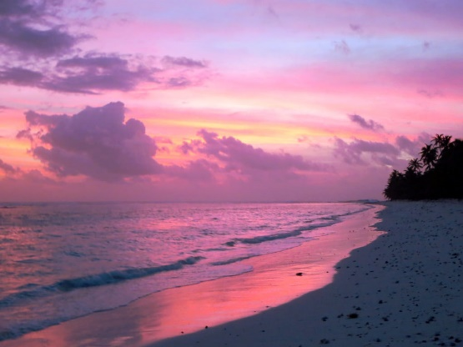
The colour palate goes for a simple off-black and white for a majority of the websites content, to ensure readability. The exception is using not bright but lighter colours for what I want to be eye catching. For this website I decided on a purple and orange-yellow theme reflecting island sunsets:

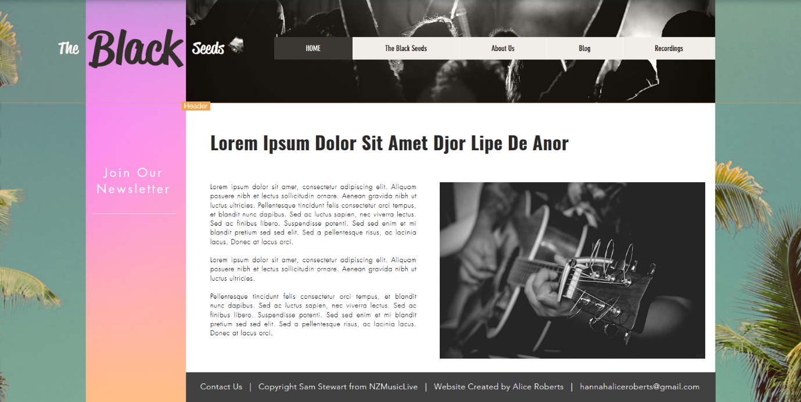

Mobile:

For the mobile version I kept things in a simple vertical plane to make the available space for images a large as possible. The newsletter button is outside the constraints of the grid, making it catch the eye of the reader. The menu button at the top of the website when clicked displays the websites menu as a sidebar from the left.

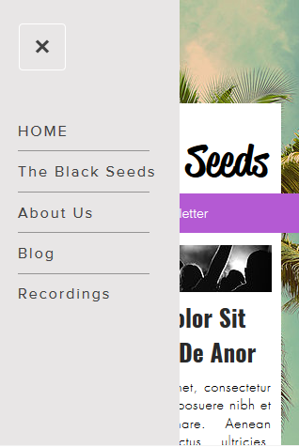
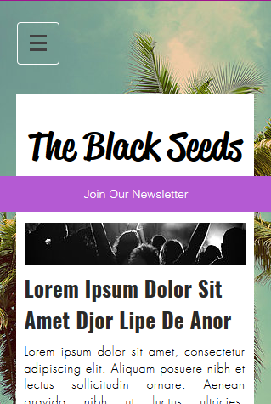
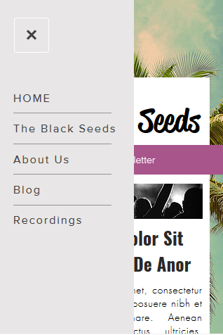
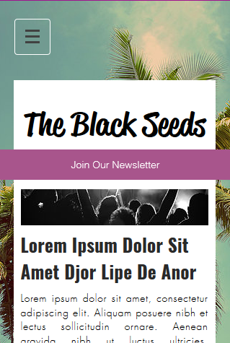
I decided however that the colour of the newsletter button was too bright and did not meet the request, so I toned down the colour:
Font I chose for the websites paragraphs was Futura Light, a web safe font, with a generic sans font as fall-back. Futura is a ‘sans-serif’ type of font, what I consciously choose because it fits the light modern style of the website. The reason I didn’t choose a ‘sans’ font is because many if not most modern websites don’t use sans font, so I believe it is a fine choice. The font I used for the headings is Oswald Bold, which is a web safe font, and the font Impact can be a fall-back, and if neither is available, a sans font. The font used for ‘The Black Seeds’ Logo is not web safe and therefore will be an image with alt text telling screen readers what the image says.

Search Optimization

The website will be tested to ensure that it is compatible and is accessible on all popular web browsers. This includes Chrome, Firefox, Microsoft Edge, Safari and Opera. It will not be tested in Internet Explorer since windows has stopped support for the program and it is obsolete. It will also be available for both phones and tablets, and will be tested on each.

All pages on the website will be linked to from the index, and the index will be linked to externally to allow googles, and other search engines to index the website easily.

The link to this website will be added to the following external websites, with clients permission.

o Muzic.Net.NZ: https://www.muzic.net.nz/forms/addartist
o NZ Musician: https://nzmusician.co.nz/contact/
o SouNZ: https://www.sounz.org.nz/about-us/contact-details

A sitemap will be provided with the website to allow search engines to crawl the website effectively in xml format. This will be submitted using the sitemaps report tool from google.

The website must be easy to find, this can be achieved using tags:

- Live Music
- Music Recordings
- New Zealand Music Live
- The Black Seeds

Domain Name

A domain name has not been reserved yet. The client has requested ‘nzmusiclive.co.nz’. To get this exact url, it will cost $19.99 for one year. However, it is noted that it is cheaper to have ‘.com’ as the extension at $1.25. It is important to the client however, that users know that the site is located in New Zealand, and is about NZ music.

If Sam Stewart does not want his name, address and phone number published in a public directory as per website regulations, he will have to purchase a additional package for privacy protection at $14.99 a year. I assume he will want this and will add it to the cost of the website. This makes a total of $51.52 a year after taxes and fees.

Hosting

The client has not chosen a host themselves, so I recommend DreamHost.

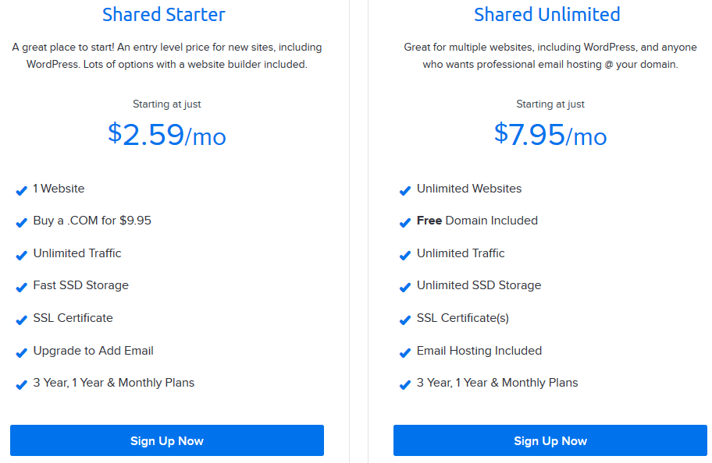
DreamHost website doesn’t have any hidden fees and is transparent. They offer a shared hosting service (website is on server with other shared websites) which is affordable, and perfect for a small starting website. It offers unlimited traffic and is stored on SSDs, for fast transfer of data. It also comes with a free SSL certificate, which allows you to tell the user that you a registered and are the website they are looking for, not a hoax. This host does not have 24/7 customer support; however they do have 24/7 online support. This plan is $2.59 a month for limited storage, and $7.95 a month for unlimited. This is the best option for this website.


Hostgators’ hatchling plan for start-up websites starts at $2.64 a month, slightly more expensive. They do however have promotional plans that when the time runs out the [rice can be substantially higher then what was initial. They also don’t offer SSD hosting on all plans. They do however have regular backups of their websites. It also provides a free SSL certificate. This website is unclear on how much storage space you get to I’d trust the previous site more.


OpenHost, a New Zealand hosting company, was also considered. It allows hosting on Linux, Windows and WordPress. Its smallest plan only offers 2GB of storage. This won’t be enough for storing recordings on the website. The next plan for 10GB of storage is at $11.00 a month, much more expansive then the other sites. This website also provides 24/7 support and backups.

All images on the website will be optimized to be the smallest possible while still maintaining quality to reduce load time for people in rural areas or slow connections and space required to host. I will be aiming for a resolution of 72ppi.

The website will likely not have to deal with a large audience of users so the hosting doesn’t have to have the capacity to deal with large numbers.

Copyright

Sam Stewart will own exclusive right to all content on this website. The website will have a copyright statement at the bottom of every page stating that all content is owned by Sam Steward and he reserves the right to download the content of the page. All images will be provided by Sam Stewart, so he owns the copyright to all images on the website.

Therefore I recommend making a copyright registration for this website. This allows you to prosecute offenders and provides a public record of ownership. If the prosecution is successful, the copyright owner may be eligible fo attorney’s fees or statutory damages. This gives you the exclusive right to:
- Copy the work
- Publishing, issuing or selling copies of the work to the public
- The right to perform the work in public
- Playing the work in public
- Showing the work in public
- Making an adaptation of the work
- Communicating the work to the public
- Authorising any other person to do any of the above

The website LegalZoom has tools allowing you to check whether you are able to copyright and gives an estimate on the cost and type of copyright:

https://www.legalzoom.com/brainnet/questionnaire.aspx?TIMESTRING=Va4v%2fKJjU%2bDfCA5VlcwiUA%3d%3d&iP=1

Using this website I estimate it will cost roughly $169. However this is not required by law, and you can still claim copyright of your work.

The domain name will not be under his copyright.

When making the website, I will add an additional link in the footer linking to the sites privacy policy, for Sam to implement. NZ privacy law says that the website must:
- Be collected for a lawful purpose connected to the function of the activity of the agency and is necessary.
- Ensure that the personal information is protected against unlawful access, use, modification or loss.

Timeline

The website is to be completed by the end of semester. See attatched Excel spreadsheet for a timeline.

Budget

With an hourly rate of $20 I estimate 60 hours of work which comes to $1200

